**IT2120 - Probability and Statistics – Lab – 05**

IT24103031 Gamage H.A.D

1. 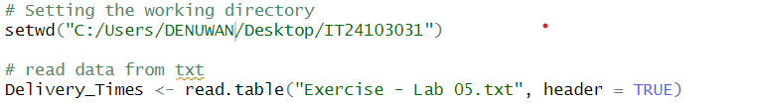
2. A computer screen shot of a program

   AI-generated content may be incorrect.  
   A graph of a delivery time

   AI-generated content may be incorrect.
3. A white background with black text

   AI-generated content may be incorrect.A white background with black text

   Description automatically generated  
   